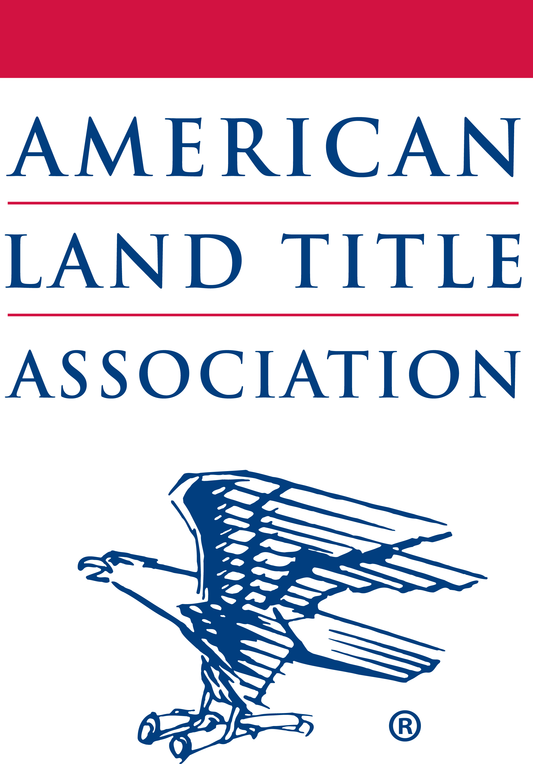
ALTA Press Release

Contact: Wayne M. Stanley
Direct Office Line: 202-261-2932
Cell: 765-432-7094
Email: wstanley@alta.org

For Immediate Release

CFPB Approach to Disclose Title Fees on Mortgage Disclosures
Not ‘Transparent,’ ‘Practical’ or ‘Accurate’
Industry Appreciates Clarification on Liability, Cure Provisions for Violations

Washington, D.C., April 8, 2016 — The American Land Title Association (ALTA), the national trade association of the land title insurance industry, released the following statement in response to Consumer Financial Protection Bureau (CFPB) Director Richard Cordray’s statements on the disclosure of the costs of title insurance in a letter to U.S. Senator Bob Corker (R-TN) today:

“We thank Senator Corker for his very helpful letter to CFPB and appreciate Director Cordray’s response. This important correspondence demonstrates that there is confusion with this complex 1,888-page regulation and that constructive oversight by Congress is productive,” said Michelle Korsmo, ALTA’s chief executive officer. “We all agree that consumers should be well-informed about the accurate costs of purchasing a home or refinancing a mortgage—including what they pay for each service during the transaction. However, as we have consistently said, the Bureau’s current approach does not provide consumers with clear information about their title insurance costs. The required calculation under TRID for title insurance fees is not “transparent,” “practical” or “accurate” as Director Cordray states in his letter and is inconsistent with the Bureau’s mission to better inform consumers.

“The title and settlement industry share the Bureau’s desire to better inform consumers. We look forward to continuing our conversation with Director Cordray and the CFPB staff to correct the calculation of title insurance policy premiums on the mortgage disclosures.

“While we disagree with the CFPB’s inaccurate disclosure of title insurance fees on the mortgage disclosures, the letter is helpful in providing clarification about how lenders and settlement agents should manage liability. In addition, the explanation about cure provisions for violations of the rule is welcomed,” Korsmo continued.

For more information about title insurance and the real estate settlement process, please click here.

###
About ALTA

The American Land Title Association, founded in 1907, is the national trade association representing 6,000 title insurance companies, title and settlement agents, independent abstracters, title searchers, and real estate attorneys. With offices throughout the United States, ALTA members conduct title searches, examinations, closings, and issue title insurance that protects real property owners and mortgage lenders against losses from defects in titles.

Connect with ALTA on Facebook here. Follow ALTA on Twitter here.

